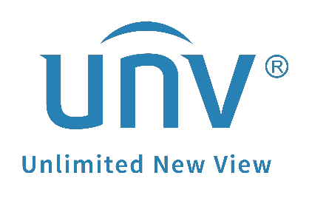

How to Add Third-party Cameras to a Uniview NVR?

How to Add a Third-party Cameras to a Uniview NVR?
Description
Note: This method is applicable to most of the scenarios, if the method still cannot solve your problem, it is recommended to consult our Tech Support Team.
https://global.uniview.com/Support/Service_Hotline/
Operating Steps
Step 1 Make sure the third-party camera and your Uniview NVR stay in the same local network and are pingable to each other (either connected to a switch or a POE port of the NVR). Make sure the camera’s system date and time are the same as the NVR’s.
Step 2 Choose the corresponding add mode you are using currently. Usually Manual or IP address.
Step 3 If the Uniview NVR can search and find the third-party camera directly, just put the correct IP of the camera here.
Note: A third-party camera’s IP address can be found through that vendor’s search tool. You can refer to it to find its correct IP and put it on the Uniview NVR when you try to add it.
Step 4 Choose ONVIF as the protocol generally and put the correct HTTP port of the third-party camera.
Note: Private protocol is used for Uniview cameras only while Custom protocol is using the RTSP stream of the third-party cameras. You can use Custom protocol to add a third-party cameras as well. Contact the third-party camera’s vendor to get its RTSP stream address and RTSP port so as to put it here.
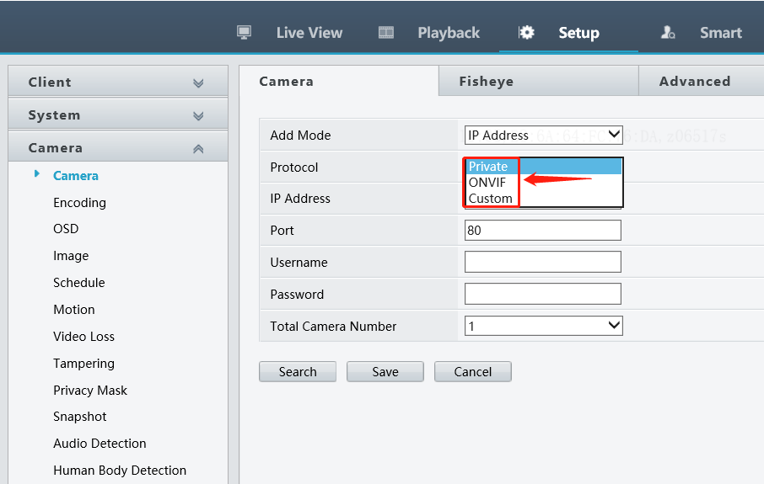
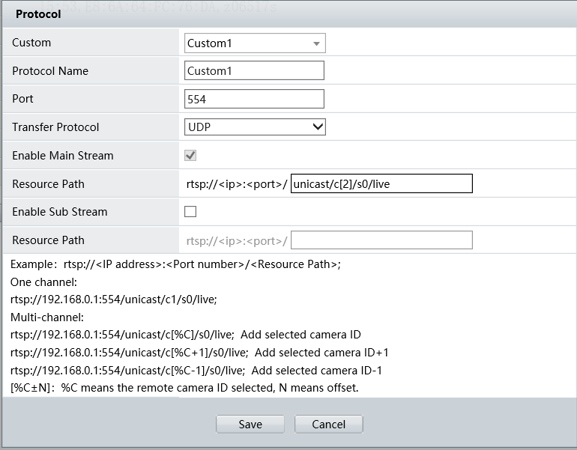
Step 5 Put the camera’s login username and password and click Save. Wait for a moment and the camera will usually come online.
Note: Some of the third-party cameras may have a login user and a separate ONVIF user, in that case, you may need to put the ONVIF user’s username and password here.
If the third-party camera fails to come online, you may refer to the guides below to see whether that helps or not.

If your third-party camera’s web interface is similar to the one below, refer to this guide to add it:
Step 1 Enable Open Network Video Interface on the camera’s web interface under Configuration>Network>Advanced Settings>Integration Protocol and select Digest&ws-username token if there is such an option for you.
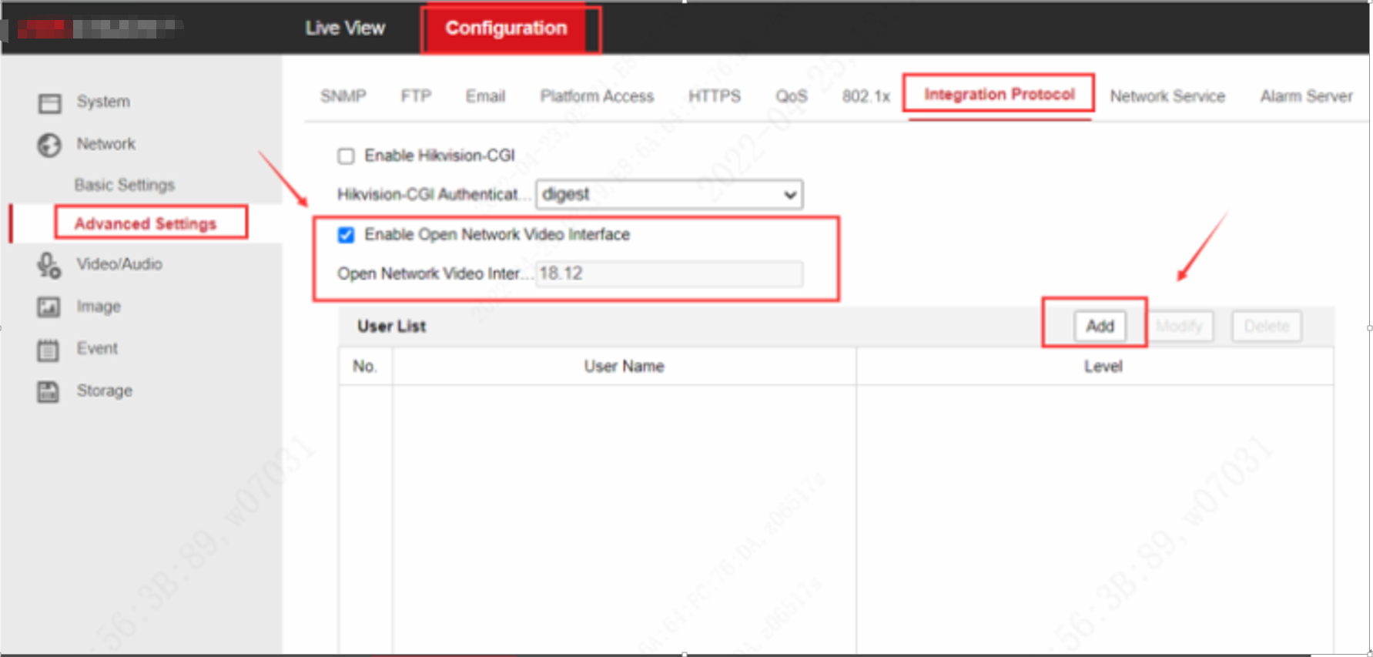
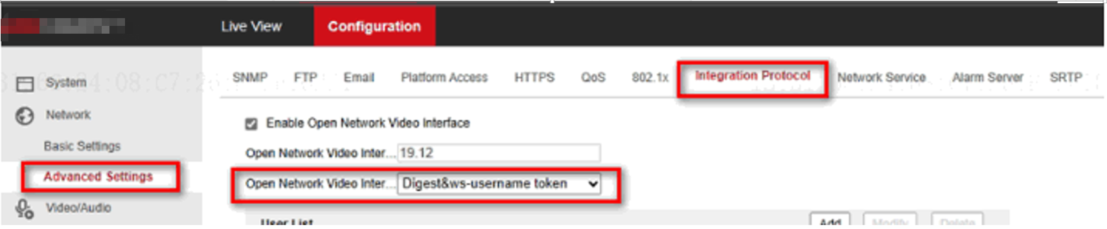
Step 2 Add a new administrator type user in the user list for ONVIF.
Eg:
Username: admin1
Password: admin123456@
Distribute Permission: administrator level, allow all the rights.
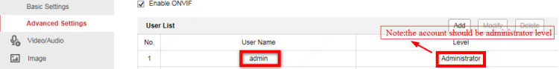
Step 3 Disable Illegal Login Lock on the camera’s web interface under System>Security>Security Services.
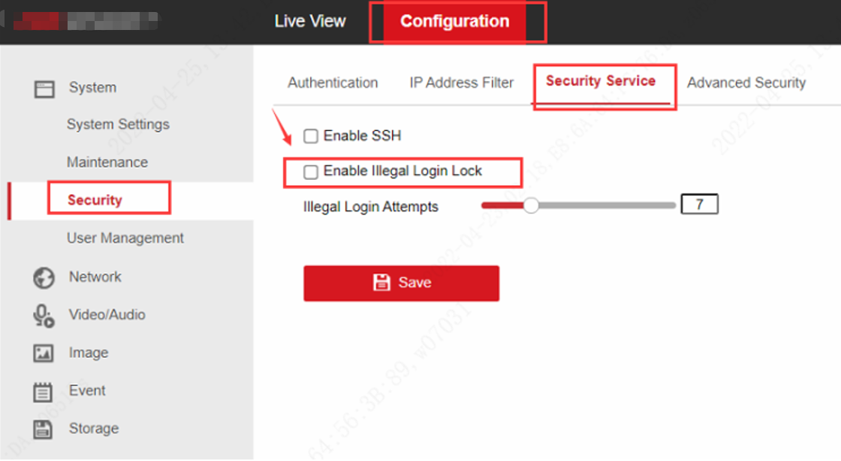
Step 4 Make sure the camera’s system date and time are the same as the NVR’s.
Step 5 Add the camera to a Uniview NVR.
Guide on GUI:
https://www.youtube.com/watch?v=n-syAeM7UaQ&list=PLrBaKYrUJkiv_ShCVIqTeIAsOxyFEljjR&index=77
Step 5.1 Click Add and put the info required on the NVR’s web interface under Setup>Camera>Camera.
Add mode: IP Address
Protocol: ONVIF
IP address: IP address of the camera, which needs to be in the same local network with your NVR.
Port: the camera’s RTSP port is usually 554 and HTTP port 80 (default). If you’ve modified these values, simply enter the new ones.
Note: Put the correct port which matches the Protocol you have chosen above.
Username: admin1, the user we created in Step 2
Password: admin123456@, the password of the user we created in step 2
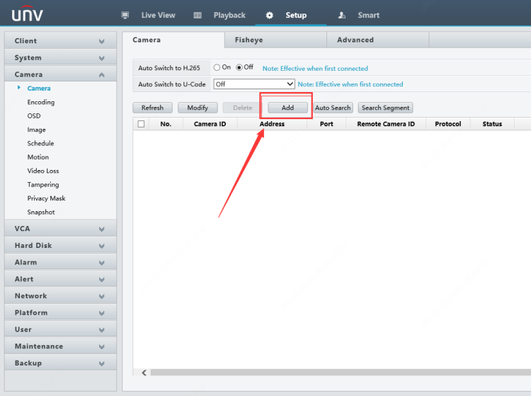
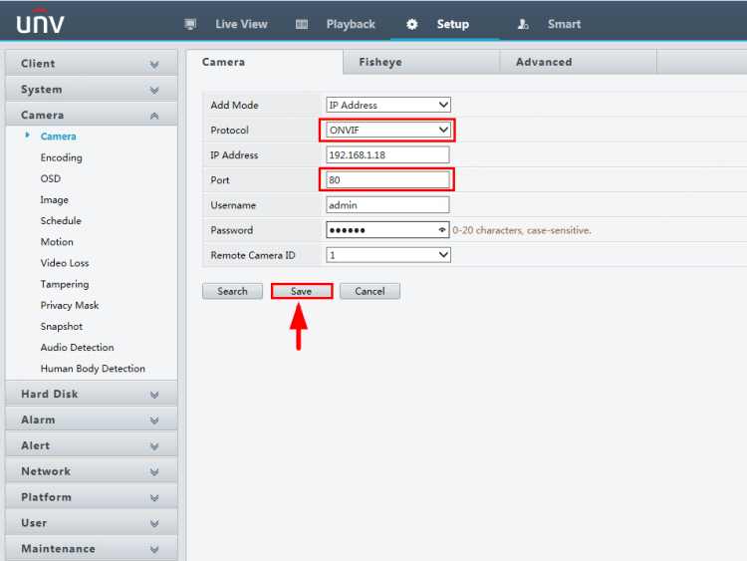
Step 5.2 Click Save and Refresh and wait for a moment.
With the same method, when you complete the configurations on the camera, you can also add cameras from Uniview NVR’s GUI.
If your third-party camera’s web interface is similar to the one below, refer to this guide to add it:
Step 1 Click Add on the camera’s web interface to add an ONVIF user (user group is administrator) under System Options>Security>ONVIF.
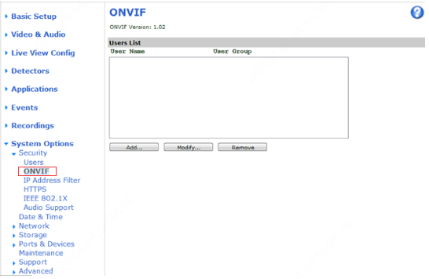
Step 2 Disable the attack protection.
Uncheck Enable replay attack protection of the camera under System Options>Advanced and click Save.
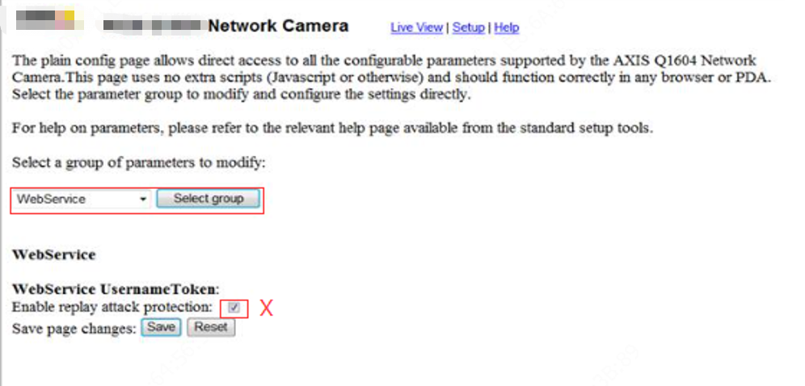
Step 3 Disable Link-Local IPv4 Address.
Uncheck Auto-Configure Link-Local Address of the camera under System Options>Network>TCP/IP>Advanced and click Save.
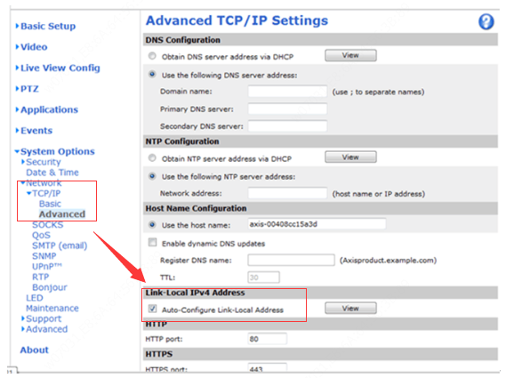
Step 4 Disable the NTP if necessary. Make sure the camera’s system date and time are the same as the NVR’s.
Step 5 Click Add on the Uniview NVR’s web interface to add the camera under Setup>Camera>Camera.
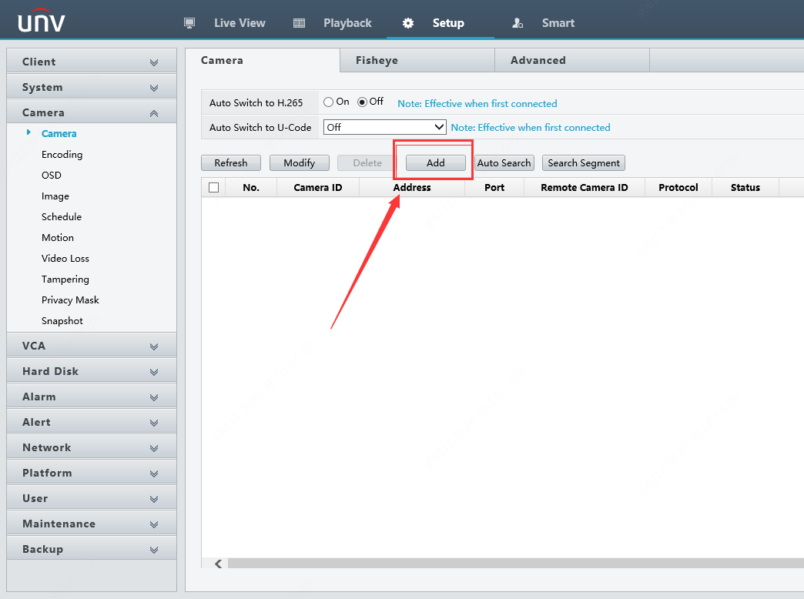
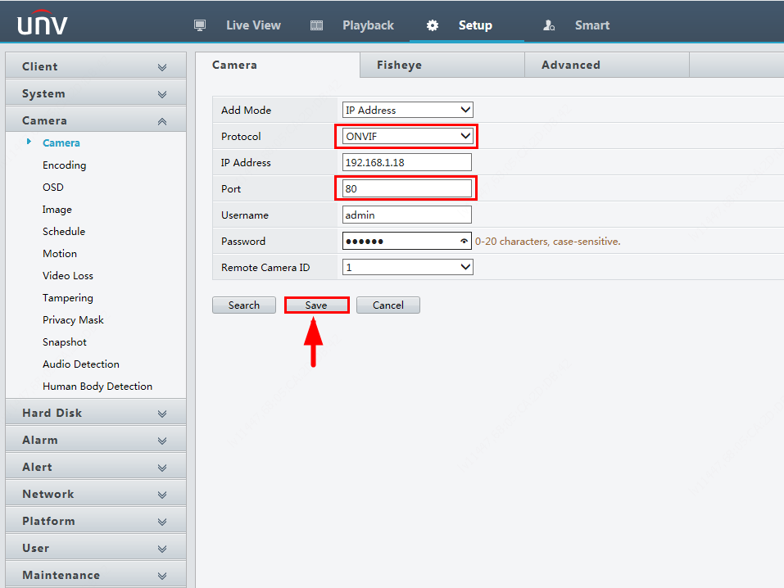
Add mode: Manual
Protocol: ONVIF
IP address: the camera’s IP address
Port: the camera’s RTSP port is usually 554 and HTTP port 80 (default). If you’ve modified these values, simply enter the new ones.
Note: Put the correct port which matches the Protocol you have chosen above.
Username: The new administrator ONVIF user we created in Step 2
Password: The password for the user we created in Step 2
Click Save and Refresh and wait for a moment.
Note: When you finish configuring the camera, you can also add it from the NVR’s monitor with the same method.

If your third-party camera’s web interface is similar to the one below, refer to this guide to add it:
Step 1 Please Turn off ONVIF Authentication on the camera’s web interface under Setting>Network>Access Platform>ONVIF, and then click Save.
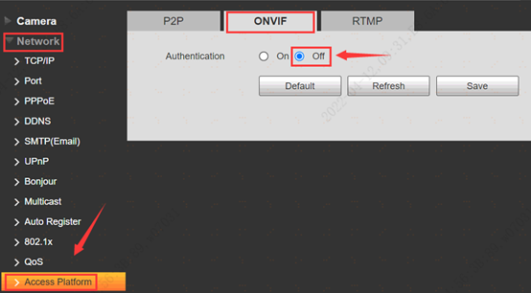
Step 2 Make sure the camera’s system date and time are the same as the NVR’s.
Step 3 Click Add on the Uniview NVR’s web interface to add the camera under Setup>Camera>Camera.
Add mode: Manual
Protocol: ONVIF
IP address: the camera’s IP address
Port: the camera’s RTSP port is usually 554 and HTTP port 80 (default). If you’ve modified these values, simply enter the new ones.
Note: Put the correct port which matches the Protocol you have chosen above.
Username: admin
Password: camera admin password
Click Save and Refresh and wait for a moment.
Note: When you finish configuring the camera, you can also add it from the NVR’s monitor with the same method.

